**NAME:** Nur Syafiqah Binti kamarol Hisham

**MATRIC ID**: 2017955793

**CLASS:** M3CS2453A

**Lab Exercise 1**

1. The **ls** command lists the contents of, and optional information about, directories and files. With no options**, ls** list the files contained in the current directory, sorting them alphabetically.

**ls**



**ls –l**

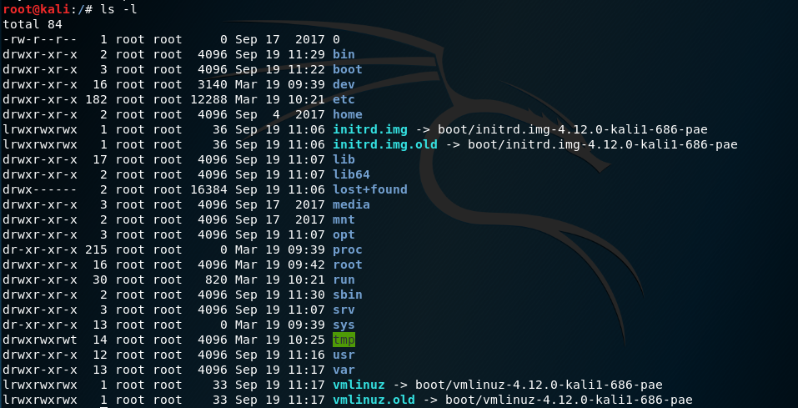

**ls –l / home /root**

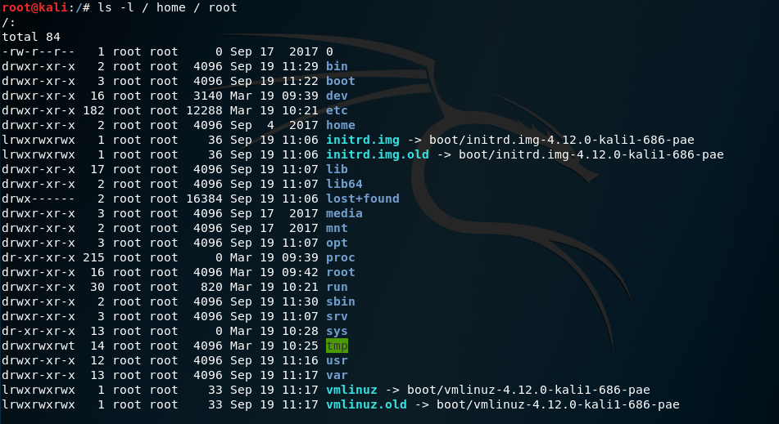

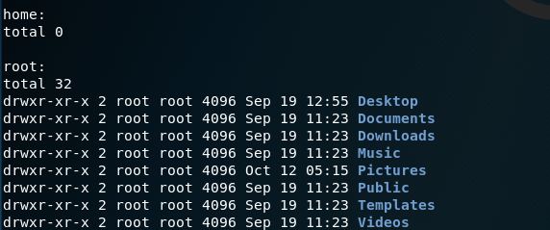

1. The **dir** command allows you to see the available files and directories in the current directory. The **dir** command also shows the last modification date and time, as well as the file size.

**dir**



1. The **mkdir** command creates new directories in your file system.

**mkdir kali**





1. **Touch** changes file timestamps. It is also an easy way to create empty files.

**Touch kali.txt**





1. The **mv** command moves, or renames, files and directories on your filesystem.

**mv kali.txt**



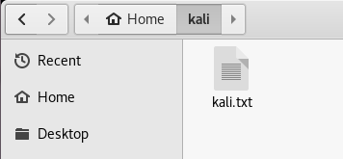

1. The **rm** ("remove") command is used to delete files. When used recursively, it may be used to delete directories.

**mkdir malware**

**rm malware**

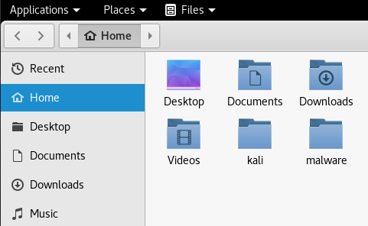



**rm --version**

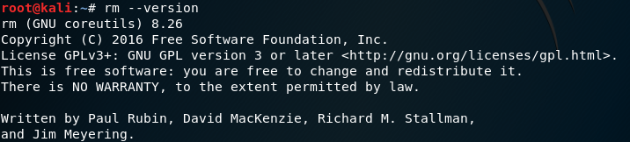

1. The **cd** command, which stands for "change directory", changes the shell's current working directory. It is a builtin command, which means that it is executed directly by your shell, instead of launching an external program.

**cd**



1. **cat** stands for "catenate." It reads data from files, and outputs their contents. It is the simplest way to display the contents of a file at the command line.

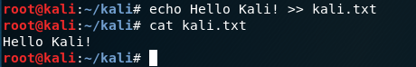

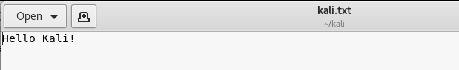

1. **pwd** Print the name of the working directory.



1. The **file** command is used to determine a file's type.

**file**

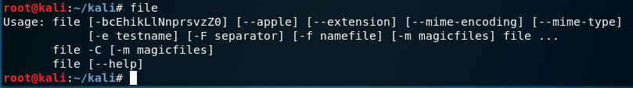

**file –l**

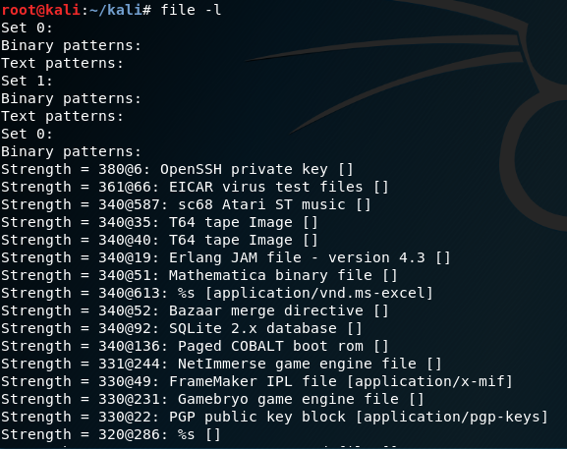

1. The **ln** creates a link to file TARGET with the name LINKNAME. If LINKNAME is omitted, a link to TARGET is created in the current directory, using the name of TARGET as the LINKNAME. ln creates hard links by default, or symbolic links if the -s (--symbolic) option is specified. When creating hard links, each TARGET must exist.

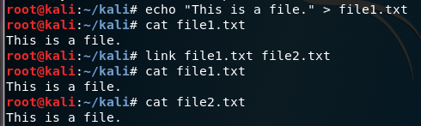

1. The **chmod** is used to change the permissions of files or directories.



1. The **chown** command changes ownership of files and directories in a Linux filesystem. 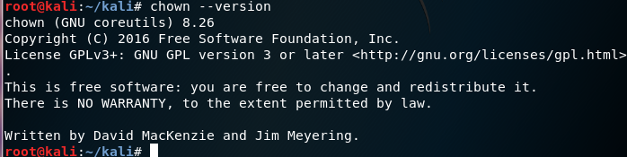
2. **more** is a filter for paging through text one screen at a time. It does not provide as many options or enhancements as less, but is nevertheless quite useful and simple to use.

**ls | more**

List the contents of the current directory with ls, using more to display the list one screen at a time.

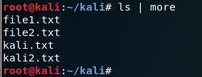

1. **less i**s a simple, feature-rich command-line file viewer.

**ls | less**

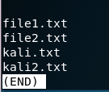

1. **grep**, which stands for "global regular expression print," processes text line by line and prints any lines which match a specified pattern.

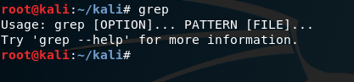

1. **wc,** or "word count," prints a count of newlines, words, and bytes for each input file.

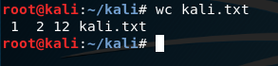

1. The **kill** command sends a signal to a process. If you don't specify which signal to send, by default the KILL signal is sent, which terminates the process.

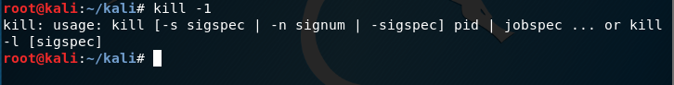

1. **ps** Reports a snapshot of the status of currently running processes.

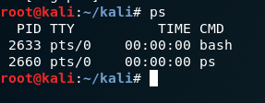

1. The **top** program provides a dynamic real-time view of a running system. It can display system summary information, as well as a list of processes or threads currently being managed by the kernel. The types of system summary information shown and the types, order and size of information displayed for tasks are all user-configurable.

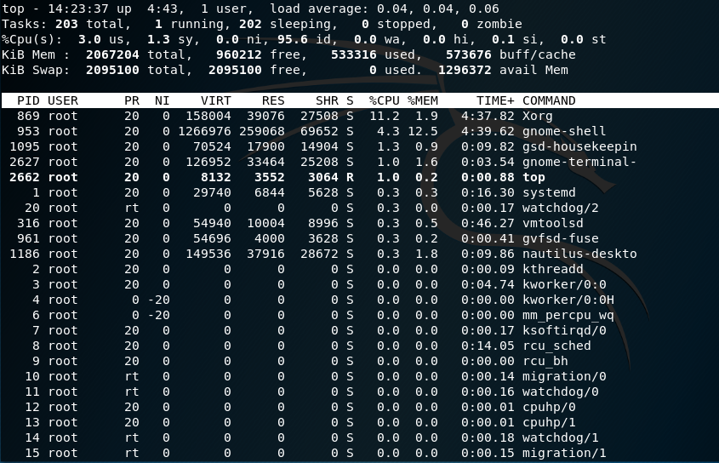

1. **Uname** Print information about the current system.

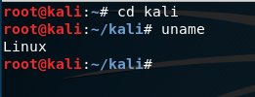



1. **uptime** tells you how long the system has been running.

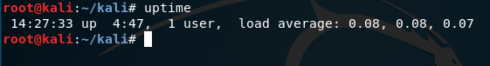

1. **Ping** Sends ICMP ECHO_REQUEST packets to network hosts.

**ping yahoo.com**

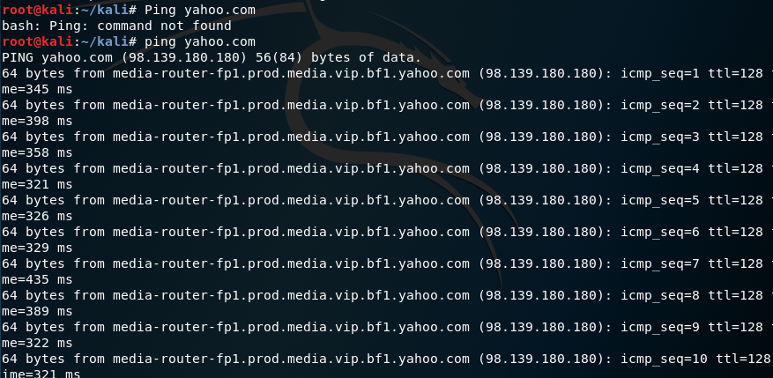

1. The **netstat** command is used to print network connections, routing tables, interface statistics, masquerade connections, and multicast memberships.

